

JCFS Chicago and people who care about you and your family recognize that bad things can happen all the time. Traumatic events can impact everyone differently, so people may need different supports.

We have created a social story with input from communication and trauma focused specialists. This story can be edited to meet a person's specific needs.

If you have any questions about how to process an event in your or a loved one's life, or need additional support, contact JCFS Chicago at 855.275.5237 or Ask@JCFS.org.

Feelings are for feeling!
Everyone shows how they are feeling in different ways.



Sometimes scary things happen that make us feel things we don't like to feel, or we don't understand.

Remember, it’s okay to feel scared, sad, happy, tired, or not sure how you feel.

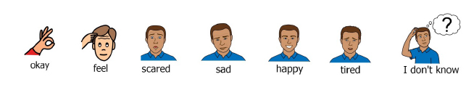Sometimes when something scary happens your body might have a reaction.

My body might feel active or calm.
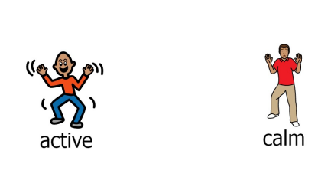

I might have a headache or stomachache.

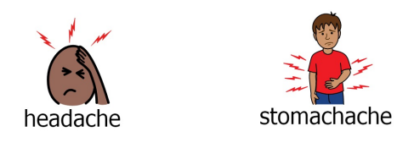

I might feel another way or the same as always.

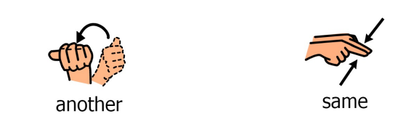

When I feel like I need help, I can do some of the things below that I love. Here are things that can help me:
Insert pictures or hand draw people or actions that you can take if more than coping strategies are needed. This might be trusted adults or community supports.

There are safe adults who I can go to if I need help. I can always ask for help:

Insert pictures or hand draw things that help you.

