

­­

**Project Esther:**

**The Chicago Jewish Adoption Network presents:**

**Transracial Adoption and the Jewish Family:**

**a parent discussion group**

Join with other parents for a conversation about the joys and challenges in parenting. Topics will be based on participant needs and may include:

* talking about race and racism
* responding to questions about your family
* managing school related issues
* fostering positive identity development

**Date:** Wednesday, June 27, 2018

**Time:** 7- 8:30 pm

**Place:** Jewish Child & Family Services

Abe & Ida Cooper Center

6639 N. Kedzie Ave.

Chicago, IL 60645

**Fee:** $20 (adjustable)

**RSVP:** Marsha Raynes**,** Manager, Project Esther

847.745.5408 [marsharaynes@jcfs.org](mailto:marsharaynes@jcfs.org)

­

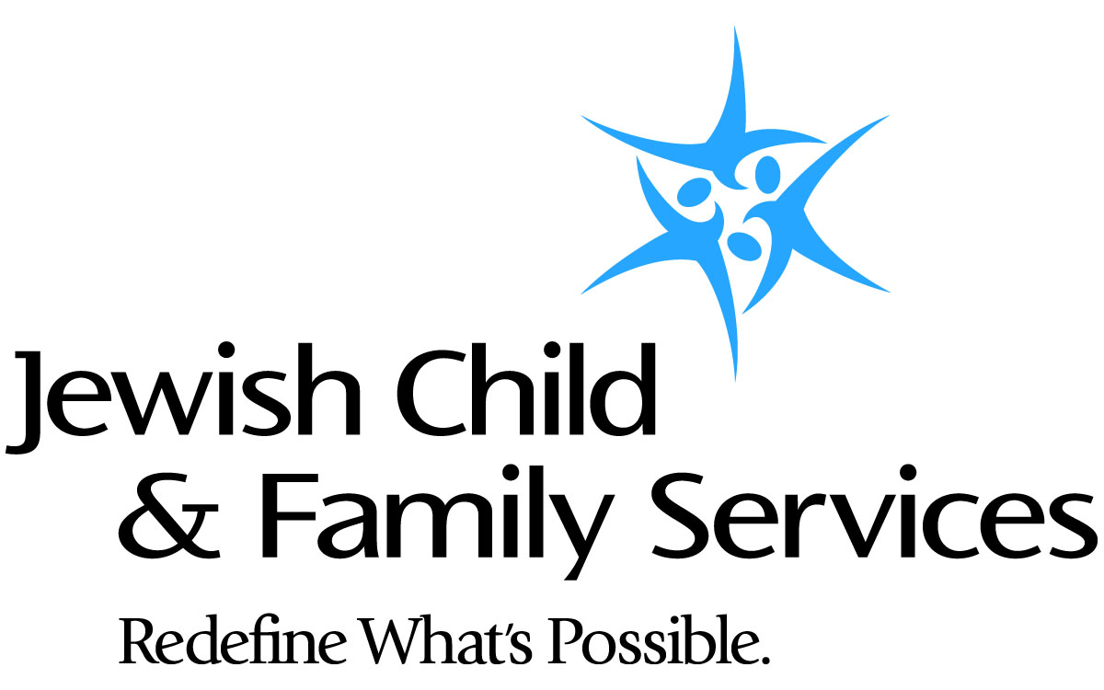

For access to help, call 855.ASK.JCFS (855.275.5237),   
email [ask@jcfs.org](mailto:ask@jcfs.org) or visit **jcfs.org.**

Jewish Child & Family Services is a partner with the Jewish United Fund in serving our community.